Explanation of the applywarp Process for BOLD Signal Extraction

In functional MRI (fMRI) analysis, brain activity is measured using BOLD (Blood Oxygen Level Dependent) signals. These signals are obtained from functional images that are typically acquired in EPI (Echo Planar Imaging) space. However, most brain atlases, such as the AAL3 atlas, are defined in a standard anatomical coordinate system called MNI space.
Because the BOLD image and the atlas are not in the same coordinate space, it is not possible to directly extract signals from the atlas regions. Therefore, the BOLD image must be transformed from EPI space to MNI space. This transformation is performed using the applywarp tool in FSL.

Purpose of applywarp
The purpose of applywarp is to transform an image from one coordinate space to another using previously computed transformations.
In this pipeline, applywarp is used to transform:
BOLD image (EPI space) → MNI standard space
Once the BOLD image is aligned with MNI space, it becomes possible to extract signals using brain atlas regions.

Required Files for applywarp
The applywarp command requires several input files that define how the transformation should be performed.
- BOLD Functional Image
bold.nii.gz
This is the original functional MRI image containing the BOLD signal.
Example dimensions:
64 × 64 × 36 × 200
Where:
- X, Y, Z represent spatial voxels
- T represents timepoints (BOLD signal over time)

- Warp File (Nonlinear Transformation)
T1_to_MNI_warpcoef.nii.gz
This file is generated by FNIRT and describes how the subject's anatomical brain (T1 image) should be nonlinearly deformed to match the MNI template.
It encodes information about:
- local stretching
- compression
- deformation of brain structures

- Transformation Matrix
func2struct.mat
This matrix is produced by epi_reg and describes the affine transformation between the functional image (BOLD/EPI) and the anatomical image (T1).
It contains parameters for:
- rotation
- translation
- scaling
This matrix maps:
EPI (BOLD) → T1 anatomical space

- Reference Image
MNI152_T1_2mm.nii.gz
This image defines the target coordinate system and voxel grid for the output image.
The output BOLD image will have the same spatial dimensions as this reference template.

Transformation Chain
To move the BOLD image into MNI space, two transformations are combined.
BOLD (EPI) → T1 space → MNI space
More specifically:
BOLD → affine transform → T1
T1 → nonlinear warp → MNI
applywarp applies both transformations in a single step.

How applywarp Works Internally?*
A key concept in understanding applywarp is that it does not start from the input voxels. Instead, it starts from the output voxels.
This approach is called inverse resampling.

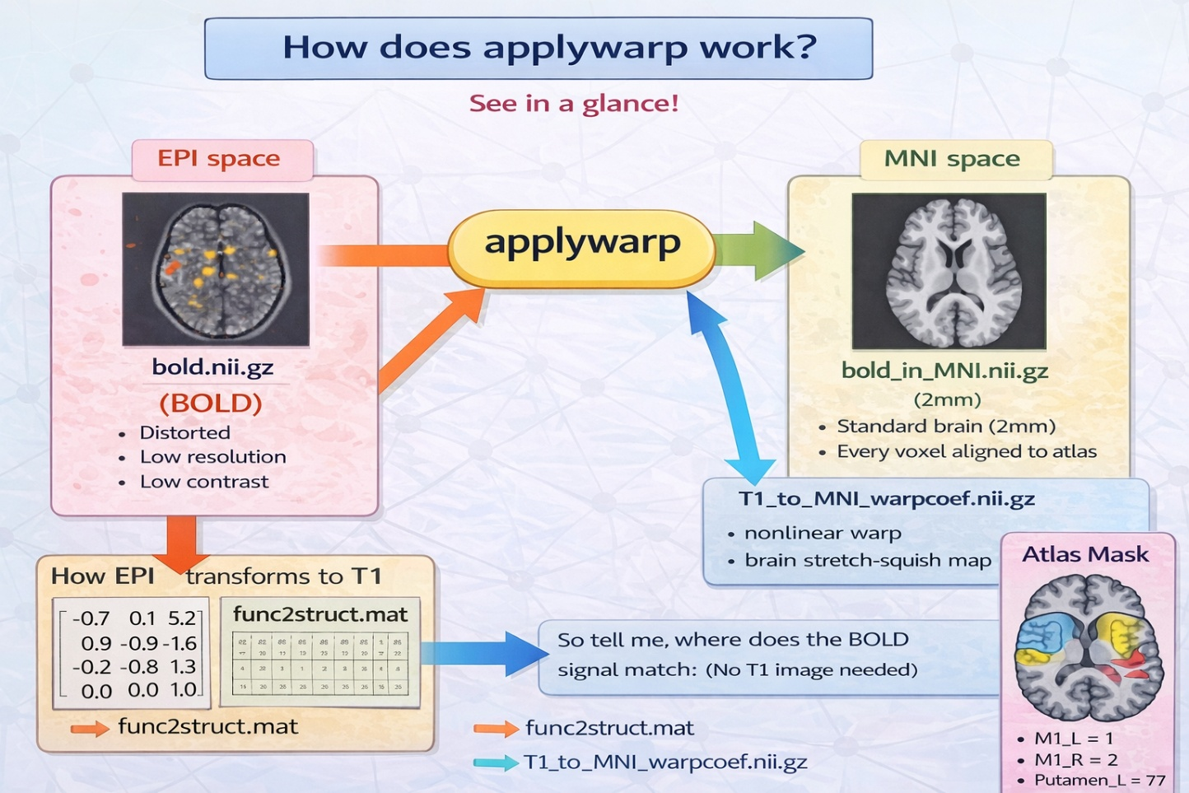
Figure: Workflow of the FSL applywarp Process for Transforming BOLD fMRI Data from EPI Space to MNI Standard Space

Step-by-Step Process
Step 1: Select an Output Voxel
Suppose there is a voxel in the output image:
MNI voxel = (40, 50, 30)
applywarp asks the following question:
Where in the original BOLD image does the signal for this voxel come from?

Step 2: Use the Warp File
The warp file:
T1_to_MNI_warpcoef.nii.gz
is used to determine where this voxel existed in the subject's anatomical brain.
Example mapping:
MNI (40,50,30)
↓
T1 (38,51,30)
This means that the MNI voxel corresponds to location (38,51,30) in the subject's T1 brain.

Step 3: Apply the Transformation Matrix
Next, applywarp uses the transformation matrix:
func2struct.mat
to determine where that T1 location corresponds in the BOLD image.
Example:
T1 (38,51,30)
↓
BOLD (35,48,27)
Thus, the signal should be taken from voxel:
BOLD (35,48,27)

Step 4: Copy the BOLD Signal
The BOLD voxel contains a time series signal.
Example:
[120, 125, 118, 122, ...]
applywarp copies this signal and assigns it to the output voxel:
MNI (40,50,30)
Interpolation:
Sometimes the calculated BOLD coordinate is not an exact voxel position.
Example:
(35.3, 48.2, 27.7)
In such cases, applywarp estimates the signal using trilinear interpolation.
This means it calculates a weighted average of nearby voxels to estimate the signal value.

Step 5: Processing the Entire Brain
The same procedure is repeated for every voxel in the output MNI image.
Conceptually:
for every voxel in MNI space:
find corresponding location in BOLD image
extract signal
assign value to output voxel
The result is a transformed image:
bold_in_MNI.nii.gz

Step 6: Atlas Interpolation (Atlas → BOLD Grid)
After the BOLD image is transformed into MNI space, the atlas must be aligned with the same voxel grid.
Atlas file:
AAL3v1_1mm.nii.gz
Since the atlas resolution may differ from the BOLD image, the atlas is resampled to match the grid of bold_in_MNI.nii.gz.
This step is called:
Atlas-to-BOLD interpolation
Nearest-neighbor interpolation is typically used to preserve integer region labels.
The result is:
AAL3_resampled.nii.gz

Step 7: ROI Signal Extraction
Now both images share the same coordinate system and voxel grid:
bold_in_MNI.nii.gz
AAL3_resampled.nii.gz
An atlas mask is created for each region.
Example:
Putamen_L = label 77
Mask:
atlas == 77
Then the BOLD signal is extracted from all voxels within that region:
ROI signal = mean(BOLD voxels inside mask)
This produces the ROI time series used for further analysis.

In conclusion, the applywarp process transforms the BOLD fMRI image from EPI space into MNI standard space using affine and nonlinear transformations. By aligning the BOLD image with the atlas coordinate system and resampling the atlas to the same grid, it enables accurate extraction of region-of-interest (ROI) BOLD signals for further brain analysis.

Summary of the applywarp Process:
- The process begins by selecting a voxel in the output MNI space image, rather than starting from the input BOLD voxels.
- The nonlinear warp file (T1_to_MNI_warpcoef.nii.gz) is used to determine the corresponding location of the MNI voxel in the subject’s T1 anatomical space.
- The affine transformation matrix (func2struct.mat) is then applied to map the T1 coordinate to the corresponding location in the BOLD (EPI) image.
- The BOLD signal from that location is extracted and assigned to the corresponding voxel in the output MNI-space image.
- If the calculated BOLD coordinate does not fall exactly on a voxel center, trilinear interpolation is used to estimate the signal value from neighboring voxels.
- This voxel-mapping procedure is repeated for every voxel in the MNI grid, resulting in the transformed functional image bold_in_MNI.nii.gz.
- Since the atlas resolution may differ from the BOLD image, the AAL3 atlas is resampled to match the voxel grid of the transformed BOLD image using nearest-neighbor interpolation.
- After alignment, atlas masks are applied to select voxels belonging to specific brain regions, and the average BOLD signal within each region is computed to produce the ROI time series.

